**Digestive Systems: Structure and Function**

The diagram below represents the digestive system of a human.

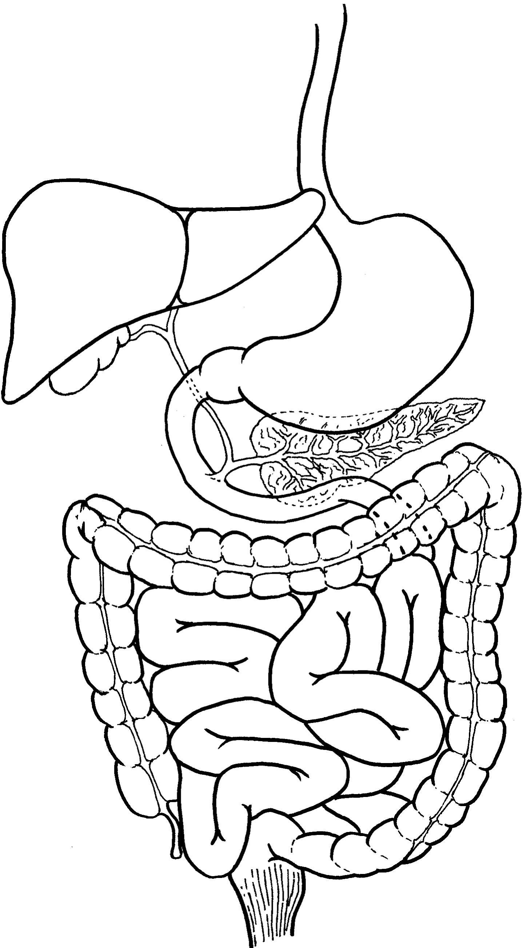

A

B

C

D

E

F

G

1. Write the name each of the organs in the boxes provided.
2. What are the two primary functions of the digestive system?
3. Write down the primary function of each of the following structures?

|  |  |
| --- | --- |
| A |  |
| C |  |
| G |  |

1. Name the chemical stored in and secreted by organ D.
2. Explain how the chemical stored in organ D aids in the digestive process
3. If a blockage occurred in the tube leading from organ D to the duodenum, what would be the effect on the digestive process?
4. Name three different types of chemicals secreted by organ E.
5. Name the process by which food moves along organ A? ______________________
6. Explain why humans need to digest their food.
7. Describe the role of organ B in processing glucose and amino acids.

**Functions of the liver**

The diagram below shows the main functions of the liver and its relationship to other organs.

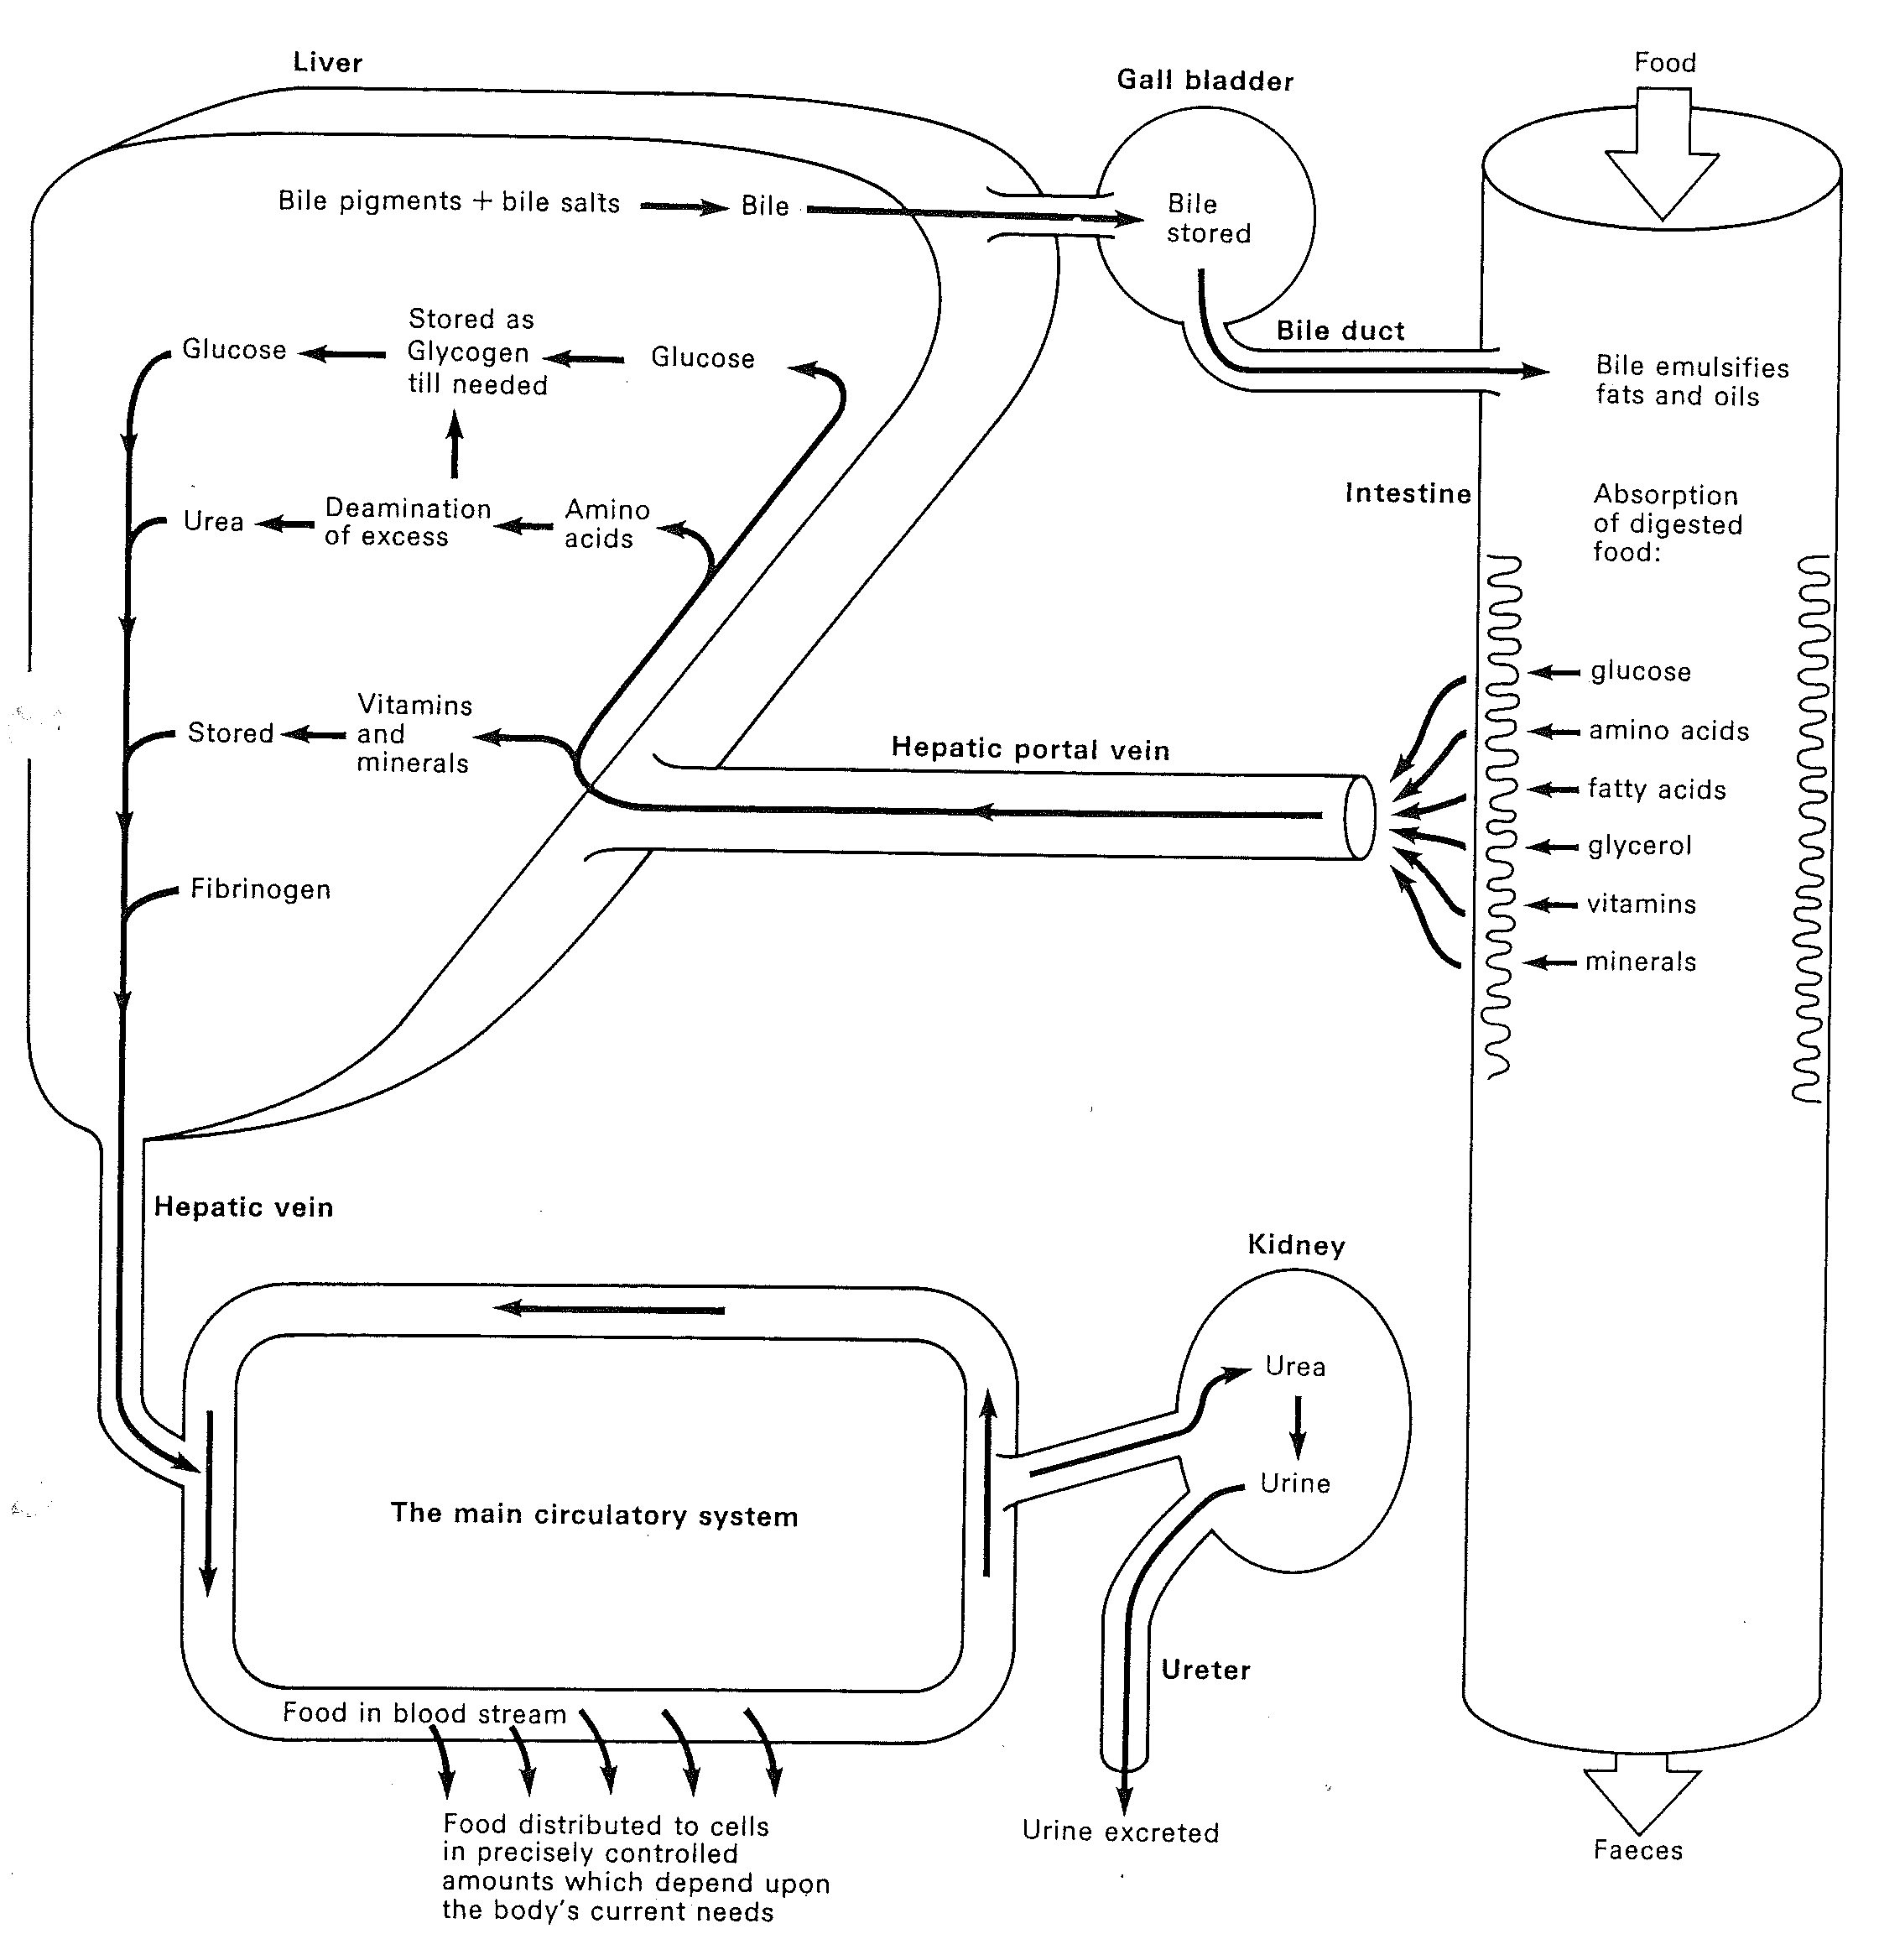

1. What is the function of the hepatic portal vein? Identify where it starts and where it ends?
2. What does the liver do to glucose before it is stored?
3. Describe how the liver is able to regulate blood glucose concentration.
4. Why are some amino acids converted to glucose in the liver?
5. Urea is toxic. How is urea removed from the body?
6. Describe the role of bile in digestion
7. Identify two substances that are produced in the liver and are found in the plasma.
8. List two substances (other than glucose) that are stored in the liver.

**Enzymes**

A type of amylase found in saliva acts on starch. In an experiment a student investigated the effect that pH had on the rate of activity of amylase. A number of small, sterilised tubes each containing the same amount of starch and amylase were set up. Each tube had a different pH. The tubes were incubated at 37oC and after 30 minutes the relative activity of the enzyme was measured. The results are shown below:

|  |  |  |
| --- | --- | --- |
| Tube No. | pH of contents of tube | Relative activity |
| 1 | 4.5 | 7 |
| 2 | 5.0 | 47 |
| 3 | 5.5 | 71 |
| 4 | 6.0 | 84 |
| 5 | 6.5 | 73 |
| 6 | 7.0 | 40 |
| 7 | 7.5 | 7 |

1. Give a hypothesis for this experiment.
2. Describe what happens to the relative activity of the enzyme as pH increases.
3. What is the optimum pH for amylase?
4. What would happen to enzyme activity if the test tubes were incubated at 50oC? Explain?
5. What is an enzyme?
6. Briefly explain how enzyme action is affected by:
7. pH
8. high temperature
9. low temperature
10. Name the substrate for salivary amylase.
11. There are two main types of chemical reactions – catabolic and anabolic. Which type is catalysed by salivary amylase? Justify your answer.
12. The pH of the stomach can vary from 1-3 due to the secretion of HCl by cells in the stomach wall. Predict what the relative activity would be for amylase if it were placed in the stomach.

**Digestive System**

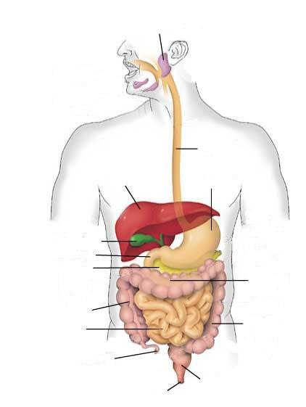

**Digestion and Absorption**

**Part 1: Digestion in the Mouth**

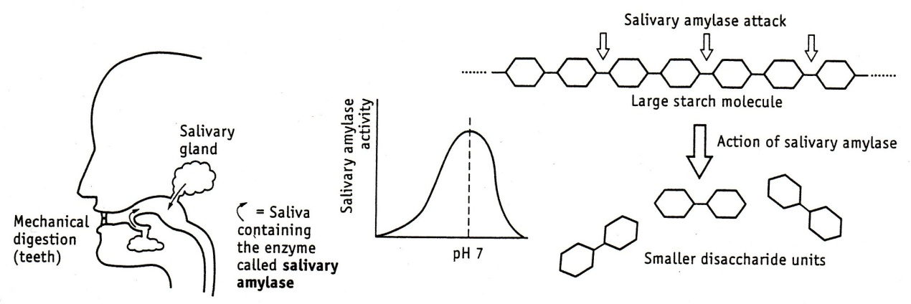

1. How does chewing (mechanical digestion) help the chemical attack on starch by salivary amylase?
2. Under which pH condition is salivary amylase most active?
3. Describe the action of salivary amylase on starch.
4. Name a common disaccharide.
5. Salivary amylase is made in the cells of the salivary glands. If a cell from a salivary gland was view under an electron microscope, which types of organelles would you expect to be abundant? (Salivary amylase is made from protein.)

**Part 2: Digestion in the Stomach**

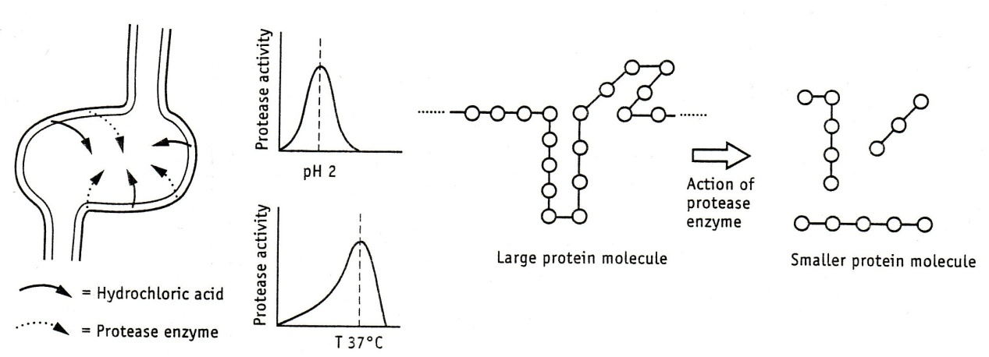

1. Under which conditions of pH and temperature is gastric protease (pepsin) most effective?
2. Give two functions of the HCl acid in the stomach.
3. Describe the action of gastric protease.
4. How is the stomach wall protected from damage by HCl?
5. Gastric protease is made by cells in the lining of the stomach. Explain why this enzyme is not activated until after it passes out through the cell membrane.

**Part 3: Digestion in the Duodenum**

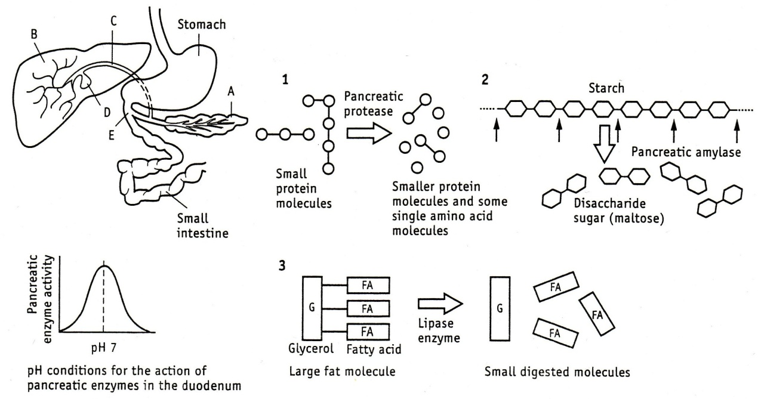

1. Complete the following table:

|  |  |  |
| --- | --- | --- |
| Organ | Name | Function |
| A |  |  |
| B |  |  |
| C |  |  |
| D |  |  |
| E |  |  |

1. Describe the action of the following enzymes.
2. Pancreatic amylase
3. Pancreatic protease
4. Pancreatic lipase
5. What is the function of the hydrogen carbonate solution in the pancreatic juice?
6. How does bile help in the digestion of lipids?

The chemical breakdown of large food molecules to small food molecules is completed in the small intestine.

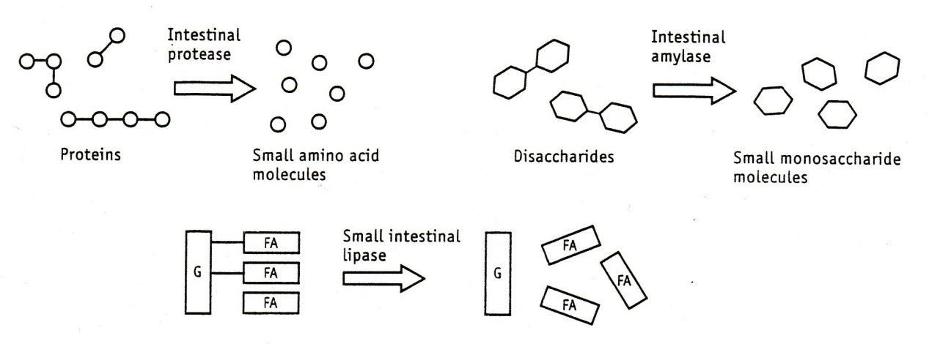

1. Name the smallest molecules produced by chemical digestion.

**Part 4: Absorption in the small intestine**

1. What happens to these small molecules in the small intestine?
2. Describe three features of the small intestine surface area that make it ideally suited to absorption.
3. By which processes do small food molecules move into the blood across the surface of the villus?

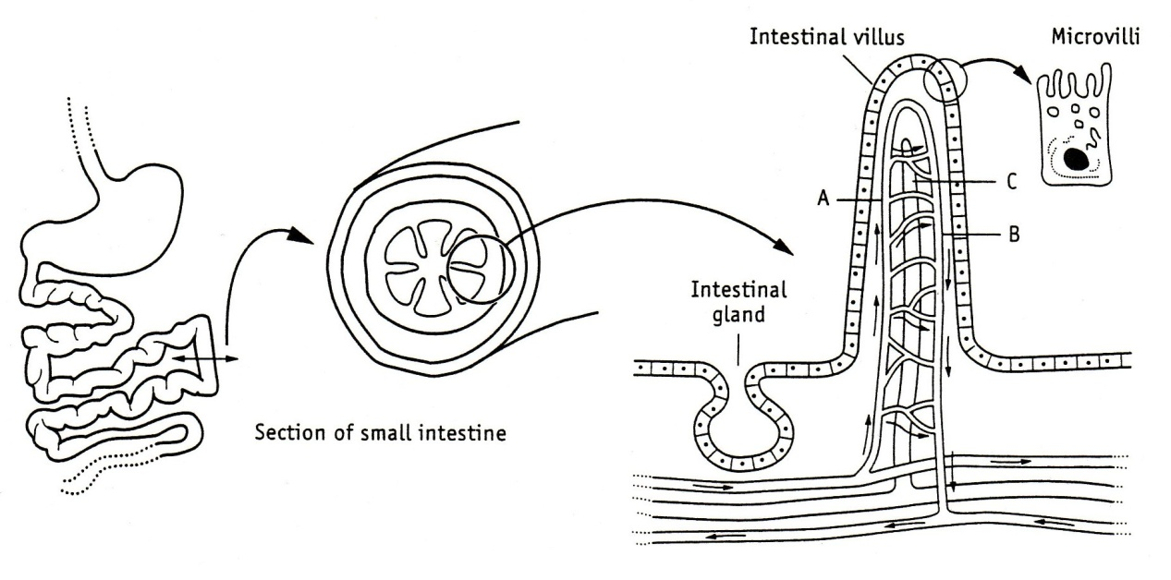

1. Point A and B on the diagram above represent parts of the capillary in the villus. In the table below compare the chemical composition of the blood at point A with that at point B as it circulates through the villus.

|  |  |  |
| --- | --- | --- |
| Chemical in blood | At point A | At point B |
| Oxygen |  |  |
| Carbon dioxide |  |  |
| Glucose |  |  |
| Amino acids |  |  |
| Mineral ions |  |  |
| Water |  |  |

1. Name two products of lipid digestion that would be present in lymph leaving the villus via the lacteal (labelled C)